**QUESTION 1**

Rewrite and run below codes.

*import numpy as np*

*import pandas as pd*

Then, perform all these tasks:

1. Read file named *Drug Seizure Statistics.xlsx.*
2. Display the first 7 rows of *df_drug*.
3. Check whether *df_drug* has any missing values.
4. Permanently drop any rows that contain less than 4 observation values.
5. For the remaining missing values, replace them with value 0, permanently.
6. Find the number of rows and columns of *df_drug* Dataframe.
7. Find the data type of each column of *df_drug* Dataframe.
8. Add a column *Mean* to store the average of each drug seizure for 2013-2018.
9. Determine whether there is any duplicate drug in *Type of drugs* column. If there is any, permanently keep the last observe values only.

**QUESTION 2**

1. Create a Dataframe named *sea_games* as depicted in Table 1 below.

Table 1

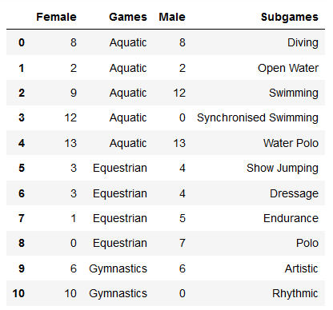

1. Create a new variable named *sea_games2* using *Games* and *Subgames* as the index. The result will displays as shown in Table 2 below.

Table 2

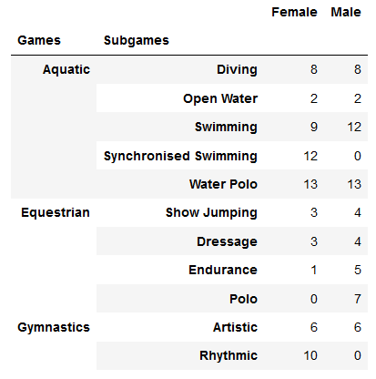

1. Based on *sea_games2* DataFrame created in (b), find the total of Male and Female athletes who involved in each *Games* - Aquatic, Equestrian and Gymnastics.
2. Create another DataFrame named *team* as shown in Table 3 below.

Table 3

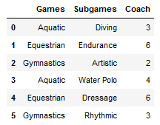

1. Merge *sea_games* DataFrame created in (a) with *team* DataFrame created in (d) using all key combinations found in *sea_games* as in Table 4 below. Set the name of this merged DataFrame as s*ea_games3*.

Table 4

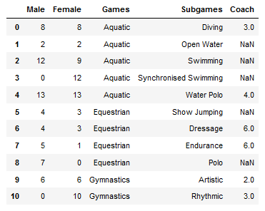

1. Fill all missing values in *sea_games3* created in (e) with value 0.